Individual Registration Form
Community Scheme Name

Your Full Name

Phone
Address:
Mobile
Email
Postcode:

Preferred Payment Method
Direct Debit (please complete mandate overleaf) ☐
Debit Card ☐
Credit Card (2% transaction fee) ☐
What quantity of oil do you anticipate buying per order?
500 ☐ 1,000 ☐ Greater than 1,000 ☐ litres

Data Protection
By returning this form you are giving permission for Norfolk RCC to store your details on our secure database. We will use this information to administer the Thinking Fuel scheme. We will also provide you with information on other services provided by Norfolk RCC. We may share your information for the purposes of administering this scheme, this includes passing information to our partners, suppliers and the local coordinator (contact details only). If you wish to have your personal details removed from our database you may do so at any time by contacting us in writing (data protection number Z9913505)
Please return this completed form to: Norfolk RCC, Ambassador Way, Greens Road, Dereham, NR20 3TL. For membership queries please call 01362 698216. office@norfolkrcc.org.uk . www.norfolkrcc.org.uk
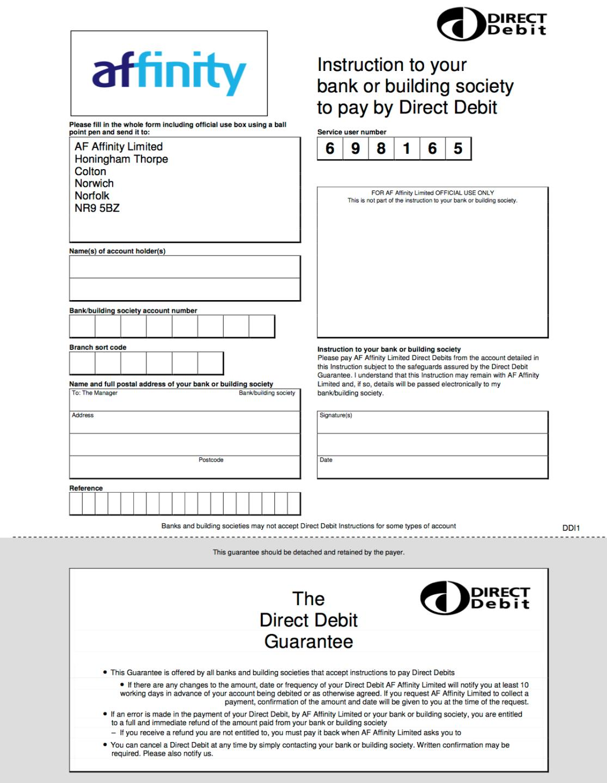
Address:

