West Dereham Parish Council

FARM TENANCY TO LET
Allotment Land off Hilgay Road, West Dereham
7.98 Hectares (19.7 Acres)
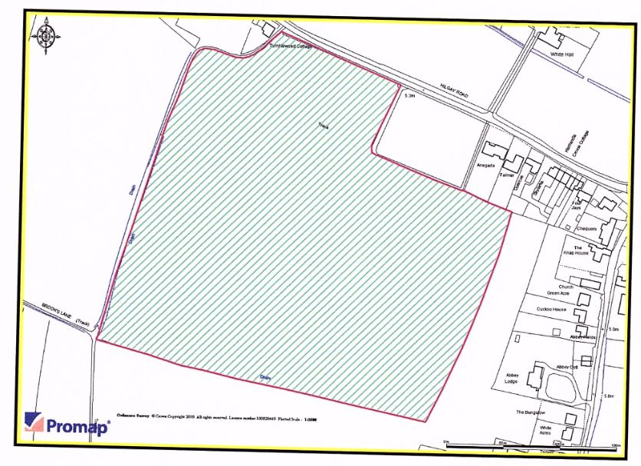
TO BE LET BY FORMAL TENDER
FOR SUBMISSION DETAILS EMAIL: clerk@westderehamparishcouncil.uk
FOR SUBMISSION DETAILS
COMMENCING 11TH OCTOBER 2017
THREE YEAR FARM BUSINESS TENANCY
CLOSING DATE FOR TENDERS IS 1ST AUGUST 2017

